**Software Design & Architecture**

**Assignment No. 2**



**Session: 2021**

**Submitted by:**

**Wali Muhammad 2021-SE-39**

**Submitted to:**

**Sir Zeeshan Ramzan**

Department of Computer Science, New Campus

**University of Engineering and Technology Lahore, Pakistan**

**UML Class Diagram**

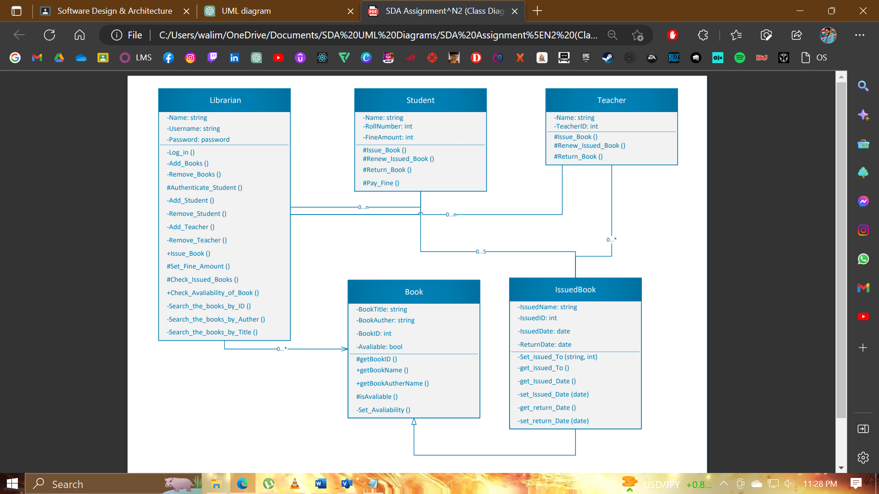

**Class Diagram Explain**

In this UML Class Diagram, there are five class Named Librarian, Student, Teacher, Book and Issued_Book.

|  |  |
| --- | --- |
| Class Name | Attribute & Functions |
| Librarian | The Librarian class has attributes such as username and password, and methods for logging into the system, authenticating the student by StudentID, Add/Remove Student/Teacher/Book and searching for books by ID, title, author name etc.  The Librarian class would likely have a private or protected attribute to store the login credentials for the librarian, which should not be accessible to other classes or components in the system.  The Librarian class would have public functions to authenticate students, search for books, and issue/return books, as these are the primary functions that the librarian would perform within the system.  The Librarian class would have private or protected functions to manage the internal state of the Book and Student/Teacher classes, such as updating the availability of books or checking the number of books issued to a particular student. These functions should not be directly accessible to other classes or components in thesystem. |
| Student | The Student class have attributes Name, rollNumber, FineAmount and methods for issuing and renewing books, as well as paying fines. |
| Teacher | The Teacher class has an attribute Name, TeacherID and methods for issuing and renewing books. |
| Book | The Book class has attributes such as bookID, title, authorName, and available, indicating whether the book is currently available or not. |
| Issued_Book | The Issued_Book class represents the process of issuing a book to a student or teacher, and has attributes such as IssuedName, IssuedID, issueDate, and returnDate. |

**Relation Between Classes**

1. The Librarian class has a unidirectional association with the Book class, indicating that the librarian can search for and manage the books in the library.
2. The Student and Teacher classes have no relationships with each other.
3. The Student and Teacher classes have no relationships with the Book class directly.
4. The Issue_Book class has a generalization relation with the Book class, indicating that a book issuance involves a specific book.
5. The Issue_Book class has a unidirectional association with the Student and Teacher classes, indicating that a book issuance involves a specific student or teacher.
6. The Student and Teacher classes are connected to the Librarian class through an association relationship. This means that there is a link between the Student/Teacher and the Librarian and that the Librarian can interact with the Student/Teacher through the functions and methods provided by their respective classes. In order for the Librarian class to perform these functions, it needs to be able to access information about the Student and Teacher objects, such as their roll numbers, names, and the books that they have checked out. This is why there is a relationship between the Librarian class and the Student/Teacher classes in the class diagram. For example, the Librarian class has the ability to authenticate students using their roll number, and to check how many books have been issued to a particular student. The Librarian class can also search for books by various criteria, such as ID, title, author, and publisher.

**Multiplicity**

1. The Librarian class has a multiplicity of 1, indicating that there is only one instance of the Librarian class in the system.
2. The Book class has a multiplicity of * (zero to many), indicating that there can be any number of instances of the Book class in the system.
3. The Student class has a multiplicity of zero to five with Issue_Book class, indicating that there can be zero to maximum of five number of Books a Student can Issue in the system.
4. The Teacher class has a multiplicity of zero to n with Librarian class, indicating that there can be n number of instances of the Teacher class in the system.
5. The Student class has a multiplicity of zero to n with Librarian class, indicating that there can be n number of instances of the Teacher class in the system.
6. The Issue_Book class has a multiplicity of zero to many for the Teacher class, indicating that there can be any number of books a Teacher can issue in the system.

**UML Object Diagram**

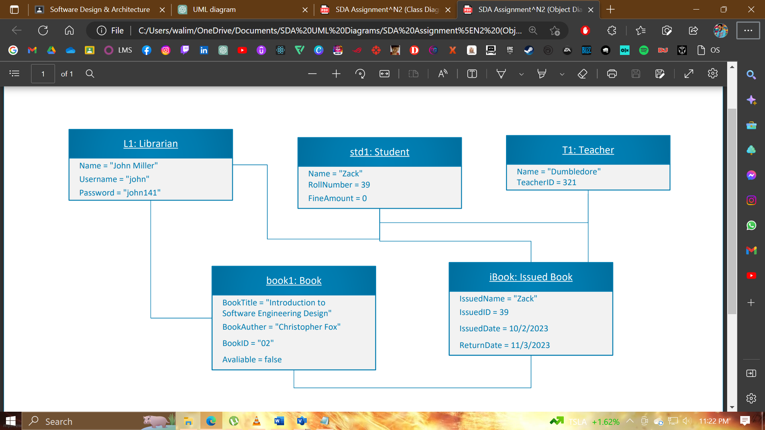

**THE END**